Update Campaign Dates

Roles and Permissions: Client Admin / Genii Admin

*Urgent: Unless you have been trained on the other aspects of this page (Edit Campaign) please don’t change anything else as it has a direct and immediate effect the campaign.*

Scope: To update the campaign dates allowing for captures during a specific timeframe.

From the Home page:

Go to Management then Campaigns Management

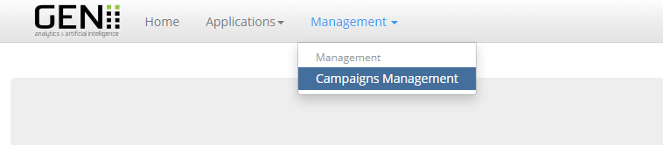

Select the Overview menu of the campaign you wish to update.

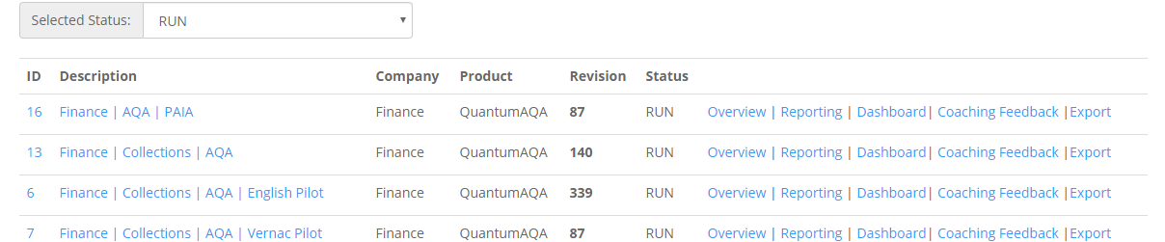

Select Edit Campaign on the Overview page

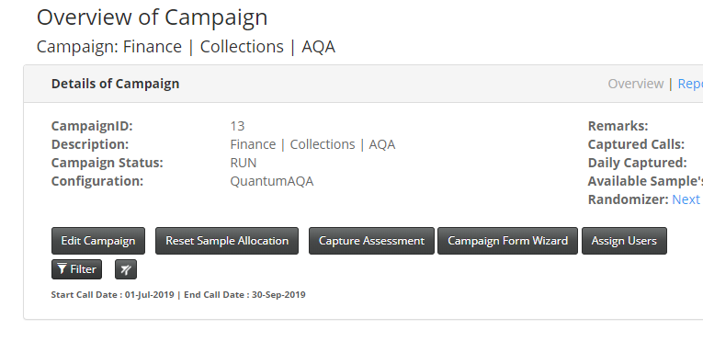

Select the Start Date and Completion Date you require.

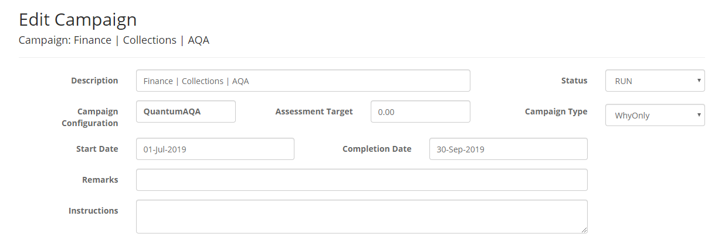



Please note:

1. This date range will become the default on all date filters across the app, including but not limited to the Overview, Reporting and Interactive Dashboards.
2. Best Practice says that you open the date range for 2 months. Your current and previous months’ call dates. This will allow you to audit the previous months assessments and capture the current month.

Scroll down to the bottom of the page and select Save

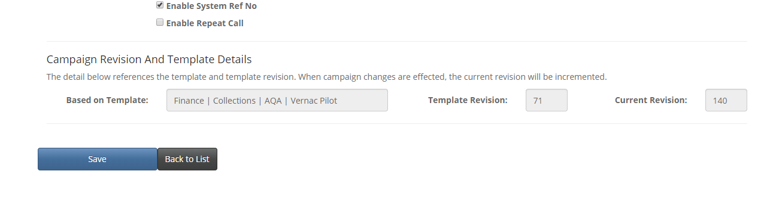

You will be returned to the Campaign Management page.

